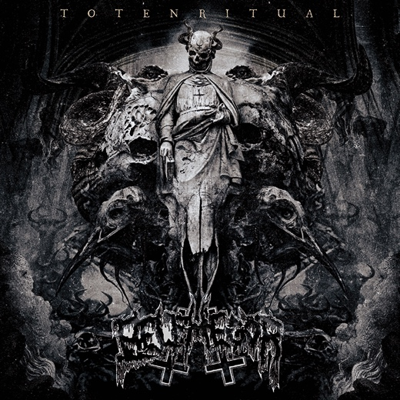

BELPHEGOR
»Totenritual«

out: September 15th, 2017

Line-up: | BELPHEGOR online:
Helmuth Lehner | Heretic grunts, chainsaw  Serpenth | Bass devastation  Bloodhammer | Drums | www.belphegor.at  www.facebook.com/belphegor  www.nuclearblast.de/belphegor
The dark days of autumn and winter are approaching as European troop BELPHEGOR plant another signpost to Hell upon the Earth's surface. One of the most consistently extreme bands on the Death/Black scene crest their throne built of bones once again to uncompromisingly attack humanity, three years after their 2014 demonstration of brutality, »Conjuring The Dead«. »Totenritual« consists of nine compositions which, blow-by-blow, silence any doubts about the supremacy of these icons of the European scene. Merciless riff force, crunchy blasts in a dark setting – 24 years after their foundation, BELPHEGOR’s inventive creativity places them head and shoulders above the rest. Anyone looking for silence, beautiful melodies and a life-affirming aura will suffocate under the power of »Totenritual.«

Even small interludes takes the listener to a safe place only for a short period, before the next brutal attack follows. The eleventh studio album of the undisputed Death/Black Metal scene conductors follows the sophisticated path of its precursors and will have their followers kneeling down in humility. The commander of death-sounds does not use a blunt corset of henchmen for his attacks on society's conventions, but demonstrates his skills as a high-class songwriter. From determined songs, embossed by an obsessed directness, to majestic ritualistic hymns - followers of darkest sermons will be led directly into the abyss. »Totenritual« enters mercilessly into the procession of BELPHEGOR's works of art: another thorn in the eye of every upholder of moral standards – the end is heralded.

For the recordings of »Totenritual«, the squad retired to Stage One Studios in Germany and Studio Mischmaschine in Austria.

For the diabolic wall of sound, the explosive material was sent across the pond and was refined in the Audiohammer Studios in Florida by Jason Suecof (Mix) and Mark Lewis (Mastering). The impressive cover artwork was again created by the Greek artist Seth Siro Anton, who has also created the striking visual countenance for »Pestapocalypse VI« (2006) and »Conjuring The Dead« (2014).

BELPHEGOR was founded in 1993 and spread like a virus within the underground. Meanwhile, their »Bloodbath In Paradise« demo has become legendary and paved the baleful path into the souls of thousands of listeners. Anti-religious with nihilistic tendencies as well as provocative topics, BELPHEGOR moved on. The debut album »The Last Supper« (1995) let the community of followers and opponents grow. Inexorably, the band pushes their destructive ways forward in the following years. BELPHEGOR become louder, more obsessed and more dynamic, and their albums now have cult status. To think about the scene doesn't work without thinking of BELPHEGOR. In 2008, the band sent their followers to the edge of hell with »Bondage Goat Zombie« and sparked an all-consuming Death Metal fire with blasting black metal influences. This masterpiece, inspired by the Marquis de Sade, is one of the most demanding works the genre has offered to this day. BELPHEGOR showed themselves equally brutal and baleful on the successors »Walpurgis Rites - Hexenwahn« (2009) and »Blood Magick Necromance« (2011). The band received a lot of great feedback for their intense live performances as well, and reached out to a big and loyal fan base. Their obscure rituals full of diabolical magick have haunted the world several times – next to extensive tours through Asia and Europe, BELPHEGOR have also completed ten tours through North America. No matter where BELPHEGOR march forth on this planet, be it on your stereo or live on stage, one thing is for sure: after the crest of their devilish death ceremony, there will only be a heap of ruins remaining!

