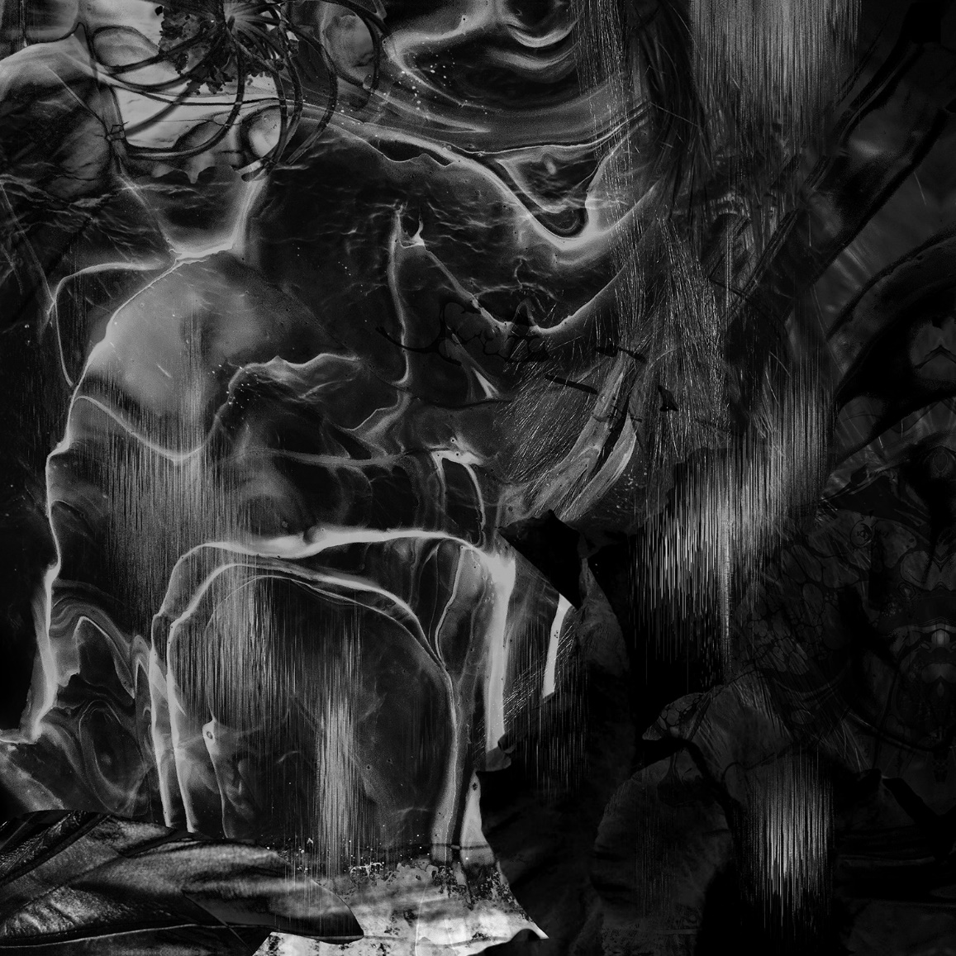 | ORANSSI PAZUZU  Muuntautuja  Release Date: 11 October 2024  Gatefold LP, CD, Digital Album  1 Bioalkemisti  2 Muuntautuja  3 Voitelu  4 Hautatuuli  5 Valotus  6 Ikikäärme  7 Vierivä usva

Four years in the making, ORANSSI PAZUZU spew forth their latest mutational meisterwerk, Muuntautuja (or Shapeshifter in English) set to be released on October 11th,, 2024 via Nuclear Blast Records. A boa constrictor of slithering, warping, interdimensional cosmic horror, Muuntautuja is in a world of its own, seeping through the speakers like irradiated sand. Ever transmuting, unsettling chords that raise the hairs on the back of your head and then pummel it with nauseating rhythms that both transport and destroy you. Muuntautuja is like an encounter with a maleficent being, well and truly unhinged, that’s out to mess with your brain. Where delays distort in a dust cloud, riffs are white noise discharge and time signatures interweave, to create the genre that ORANSSI PAZUZU inhabits alone. A convulsing mass on collision course, the air-borne sonic viral load of Muuntautuja is undeniably infectious, and bound to turn heads.
If Nasa discover a new form of metal element under the surface of Mars they would have to call it ORANSSI PAZUZU, a band that’s uncharted and pushing the boundaries of what heavy, extreme music should sound like. From their first spaced out underground Black Metal album Muukalainen Puhuu (2009), to second album Kosmonument (2011), their first album to get wider distribution, to their then-next record Valonielu (2013), which saw them delve deeper and weirder into Psychedelic Black Metal, setting the stage for Värähtelijä (2016), arguably their breakthrough record, ORANSSI PAZUZU have been impossible to pigeon-hole and a feast for those who dig deep, heavy and strange.

Not so much a reinvention of form as a creative zenith, where ORANSSI PAZUZU have struck a vein of gold in the wasteland, the irony of it is that Muuntautuja sounds like the album they have been diligently mining all along. Dense, ferocious, glistening, blistering and buzzing, Muuntautuja is like tuning in and dropping out to hostile alien signals. The title of the album, meaning Shapeshifter, is a perfect description of the ORANSSI PAZUZU that emerged from their extraterrestrial cocoon in 2024. A new form of being, but whose flesh is eerily familiar, Muuntautuja sees ORANSSI PAZUZU contort their signature noise into something truly fearsome from their critically acclaimed previous album Mestarin kynsi (2020). Noise has always been a part of the classic Black Metal sound but Muuntautuja takes it to a more shattering and violent culmination.

Bass player Ontto elaborates on Muuntautuja’s explosion of experimental and harsh sound when he talks about “noise as a compositional tool” and adds: “The noisier and the more experimental stuff came from a necessity to reinvent the way we were writing songs. The change was already in motion on Mestarin kynsi, but on the new album we really felt we wanted to shed the old skin and find new angles.”

Vocalist Jun-His agrees when he states:
“We felt that we could express things that we have been only flirting with previously. The noisier experiments started happening during live versions of Taivaan portti from the previous album, and it felt good to not leave it to that, but to expand on it.”
When the protagonist of a movie or novel starts to unravel, and the world becomes malevolent, we’d imagine introducing the beginning of the track ‘Ikikäärme’, and let the celestial science fiction of it’s sound-track take us to Ari Aster or Robert Eggers like cinematic terror. Undercurrent layers swell in an alien language, inescapable and claustrophobic. Gestating a new form of metal in their host bodies, humid, equatorial and febrile, on Muuntautuja, ORANSSI PAZUZU constantly transpose and shift key, leaving us high and dry, exposed in space with no umbilical for air.
If we delve into the centre of Muuntautuja, there is pure darkness. As the lyrics of ‘Hautatuuli’ (or “Grave Wind” in English) repeat in whispered, mantra-like succession, “gate behind a . . .gate behind a”, behind the gate there is a gate and we have to keep entering the many levels of the album’s sonic symbolism. The layers of initiation ORANSSI PAZUZU are discussing are present in their music. A resonant ritual of layers upon layers, rhythms upon rhythms. If you pass through all the gates on Muuntautuja, you find the center and that is a darkness that’s impossible to illuminate.
From the depiction of the mayhem of war in the tracks ‘Voitelu’ or themes of mass manipulation in ‘Bioalkemisti’, Muuntautuja’s concepts are colossal. The themes reach an almost mythical and religious element where Ontto explains: “In the more atmospheric tracks the subjects are introspective and mystical - Muuntautuja deals with the idea of death as a transformation into a different state of being, and ‘Ikikäärme’ is a fantasy about pursuing immortality, by becoming united with a god snake after being devoured by it.”
Drawing inspiration from eclectic sources ranging from Boredoms, Death Grips to Portishead’s Third album, ORANSSI PAZUZU mold their psychedelic alchemy into a potent brew where a tripped out Godflesh creates an alien being with Nine Inch Nails (Downward Spiral era), Beherit and My Bloody Valentine. The result is that Muuntautuja is electronically charged, both organic and inorganic in origin.
Guitarist Ikon reflects:
“Our experimentation with samplers and electronics made us step towards the weird concept of making nightmarish Rave music. We tried to find common ground between danceable rhythms and oppressive waves of noise and distortion.”

Muuntautuja transcends genre, embodying a transcendent experience that slimes listeners in its nightmare of space and metamorphosis. Jun-His muses, "For us, this album is like a sculpture made of black electric ooze."
Await the release of Muuntautuja, ORANSSI PAZUZU’s fire in the sky, where reality bends and shapes shift with each and every haunting note, and you will be visited by higher beings, though not with your best intentions entirely at heart.

ORANSSI PAZUZU - Discography:  Muukalainen puhuu (2009)  Kosmonument (2011)  Valonielu (2013)  Värähtelijä (2016)  Mestarin kynsi (2020) | ORANSSI PAZUZU ONLINE  FACEBOOK  https://www.facebook.com/oranssipazuzuband  INSTAGRAM  https://www.instagram.com/oranssipazuzu  X  https://x.com/oranssi_pazuzu  MISC.  https://linktr.ee/oranssipazuzu

